GIT TASK

- Create a GitHub account.
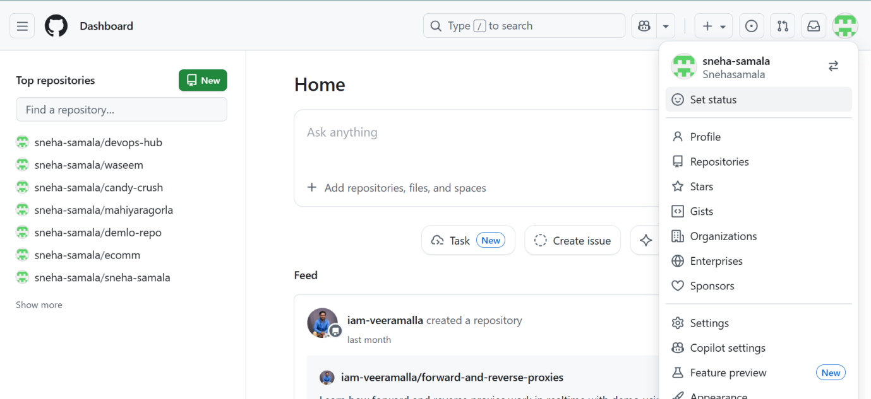

- Set up MFA (Multi-Factor Authentication) for the GitHub account using a mobile app.
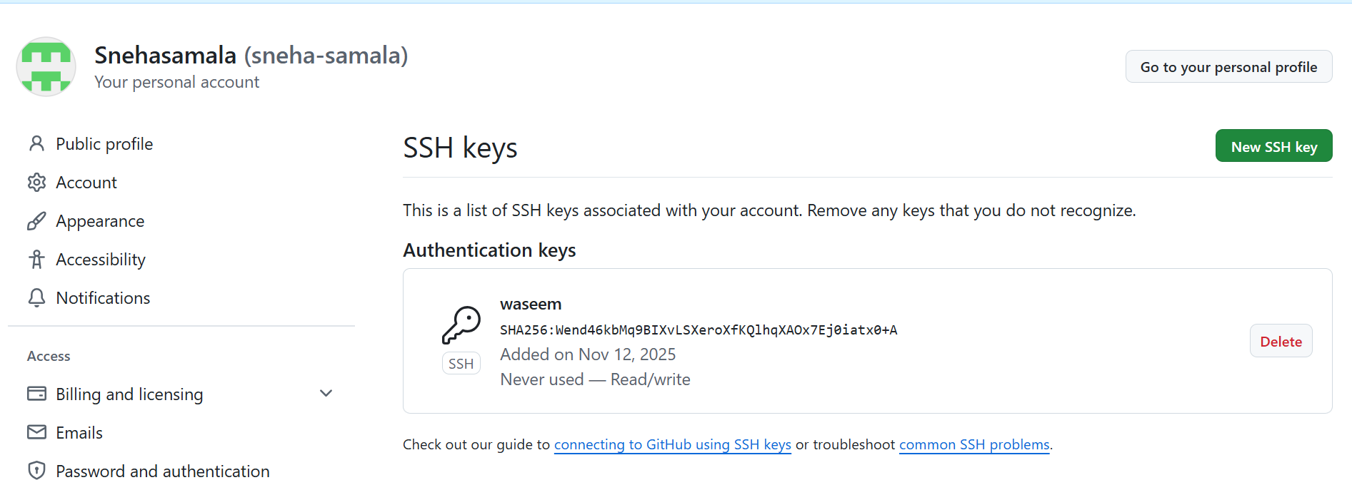
- Execute all commands shown in the video.
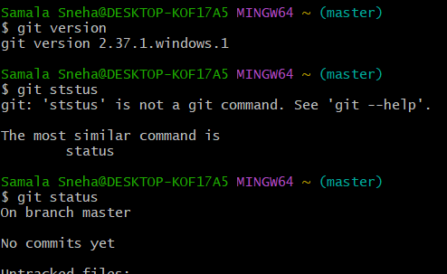
Git init : to understand what should to track
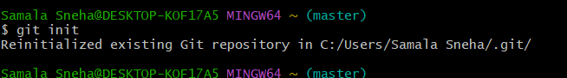
Created the name and email
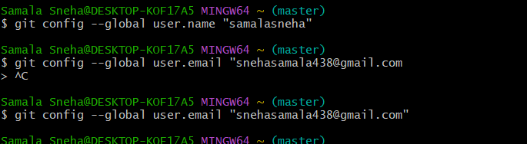
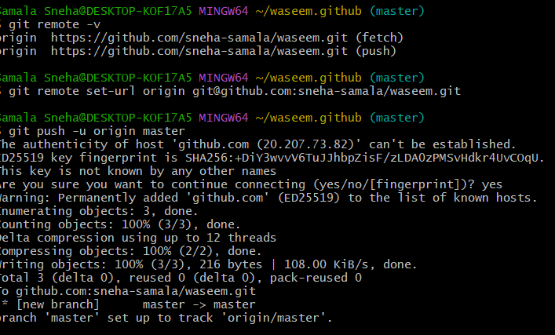
Go to central repo refresh the browser
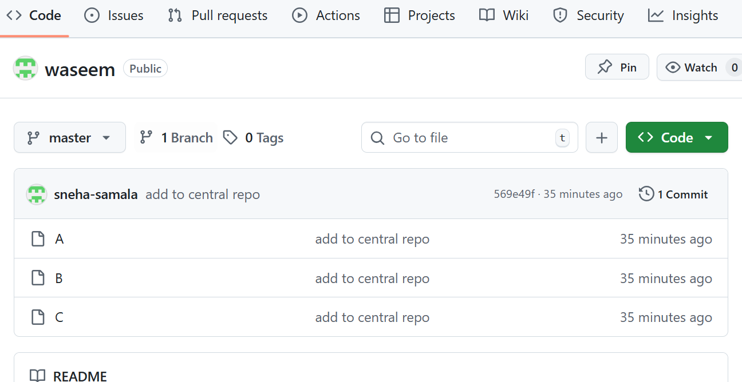
Removed the file
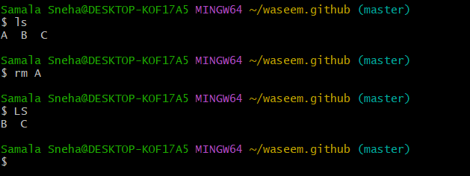
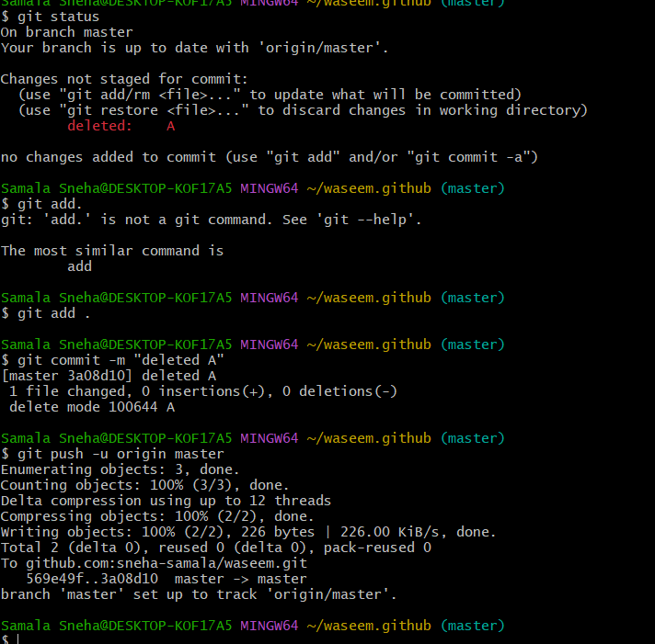

Deleted A file
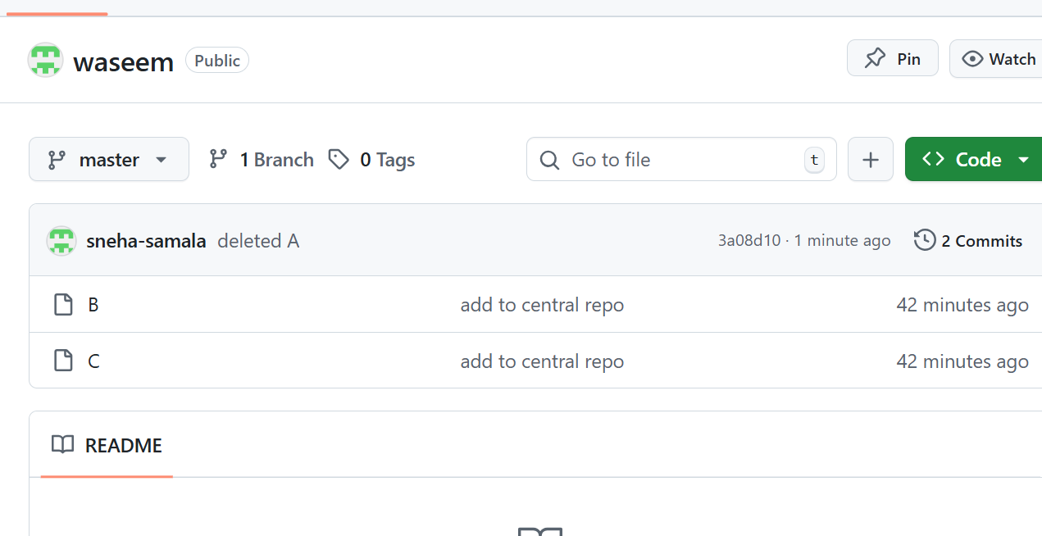
Created file
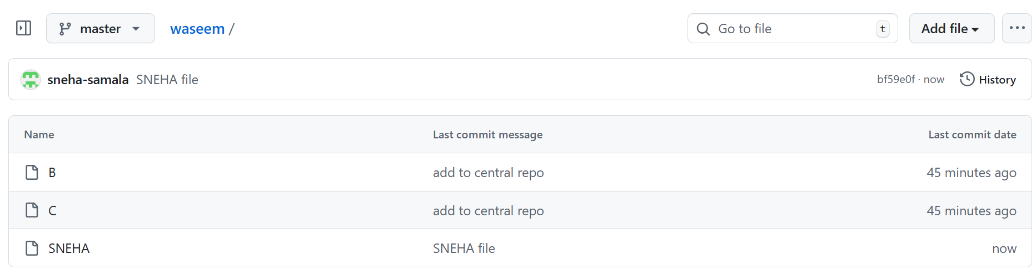
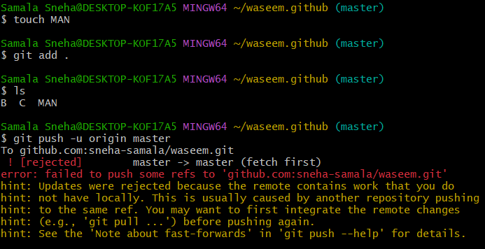
Sneha is available in local machine
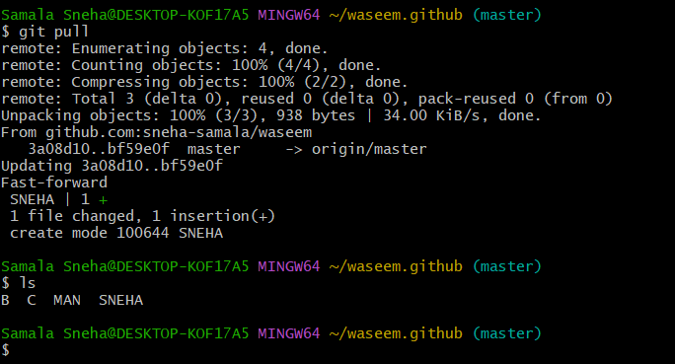
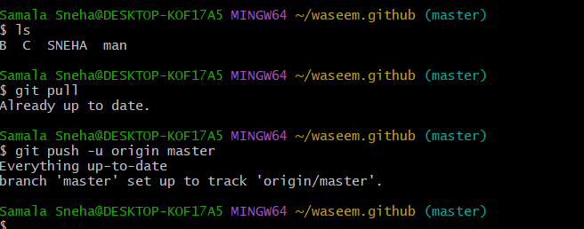

Clone central repo to local machine
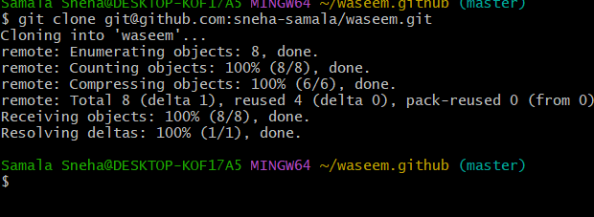
We can see directory is created : this directory is similar to project name
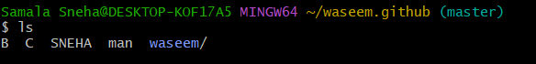
Git clone :
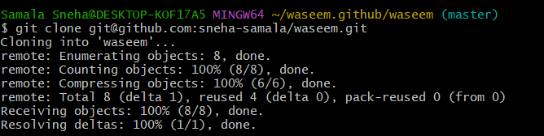
To know the commit id
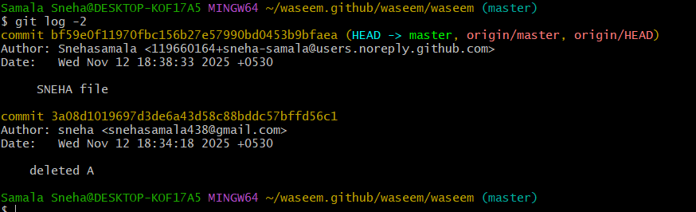
Go to the commit page
Git revert : it will help us to previous changes
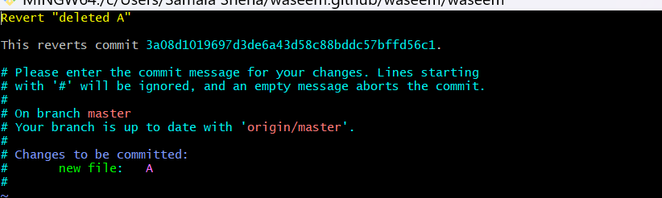
A file is added
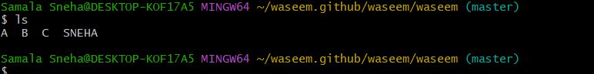
Git reset : tracking area to untracking area
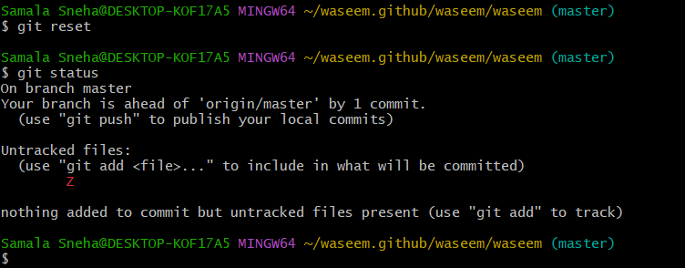
Deleted the repo
